

**Appointment for your Annual Health Check**

Dear

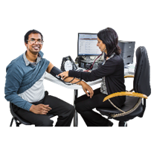

It is time for your yearly health check.



Due to Coronavirus we made some changes to keep you safe

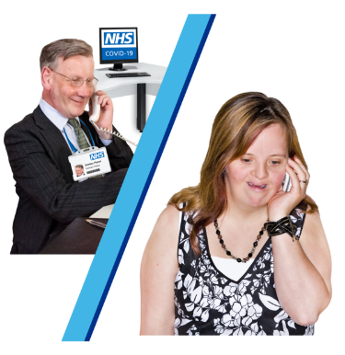

We can now complete your health check over the phone



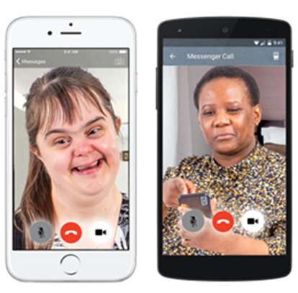

Or by video call

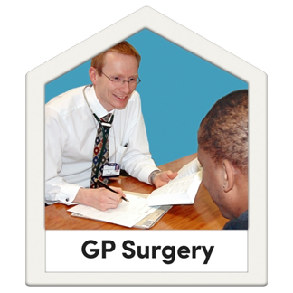

You can still come into the GP Surgery

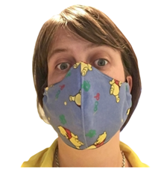

If you can you should wear a mask

How you would like to have your health check? Tell us by calling the practice on: