**Appointment for your Annual Health Check**

Dear

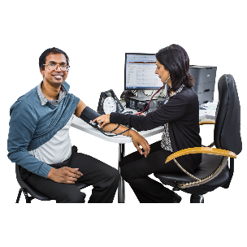

It is time for your yearly health check.

Your appointment has been booked for:

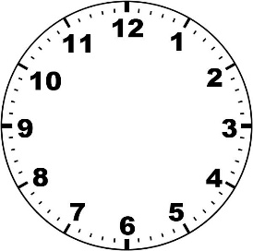

Please collect a sample bottle from the reception desk, then bring a urine sample to the appointment.

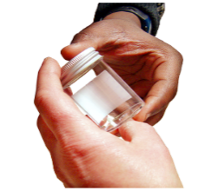

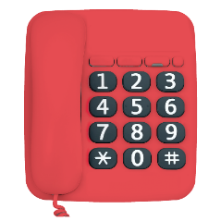

If you can’t make this date, please ring the practice on:





We can complete part of your health check over the phone

Or by video call

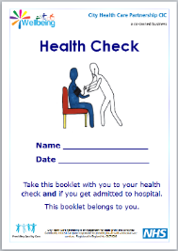

Please fill in and bring your Health Check Book to your appointment.

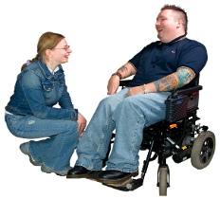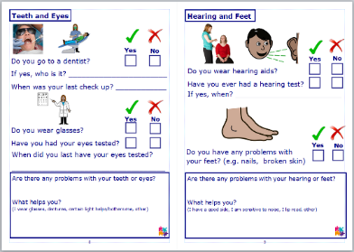

We look forward to seeing you at your Health Check.

Yours Sincerely,

(Practice Manager/Practice Nurse/Doctor)

If you would like to bring a friend, Carer or your Community Nurse with you, please bring them along.

If you need help with filling your health check book in, please ask a carer or call the practice.