**Appointment for your Annual Health Check**

Dear

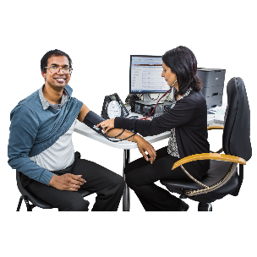

It is time for your yearly health check.



Please ring and make an appointment to see our practice staff at your GP Surgery

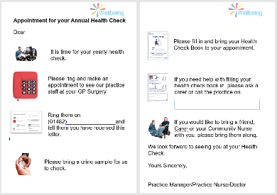

Ring (01482)_____________ and tell them you have received this letter.

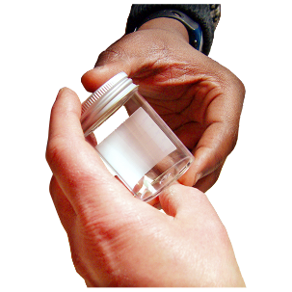

Please bring a urine sample for us to check.

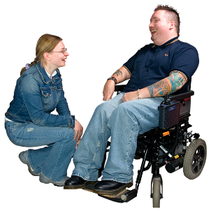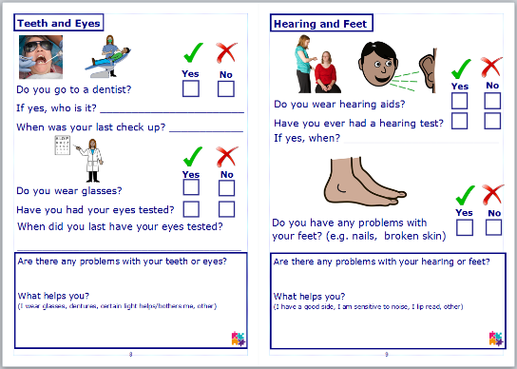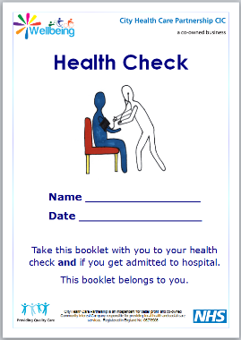

If you would like to bring a friend, Carer or your Community Nurse with you, please bring them along.

If you need help with filling your health check book in, please ask a carer or call the practice.

Please fill in and bring your Health Check Book to your appointment.

We look forward to seeing you at your Health Check.

Yours Sincerely,

Practice Manager/Practice Nurse/Doctor