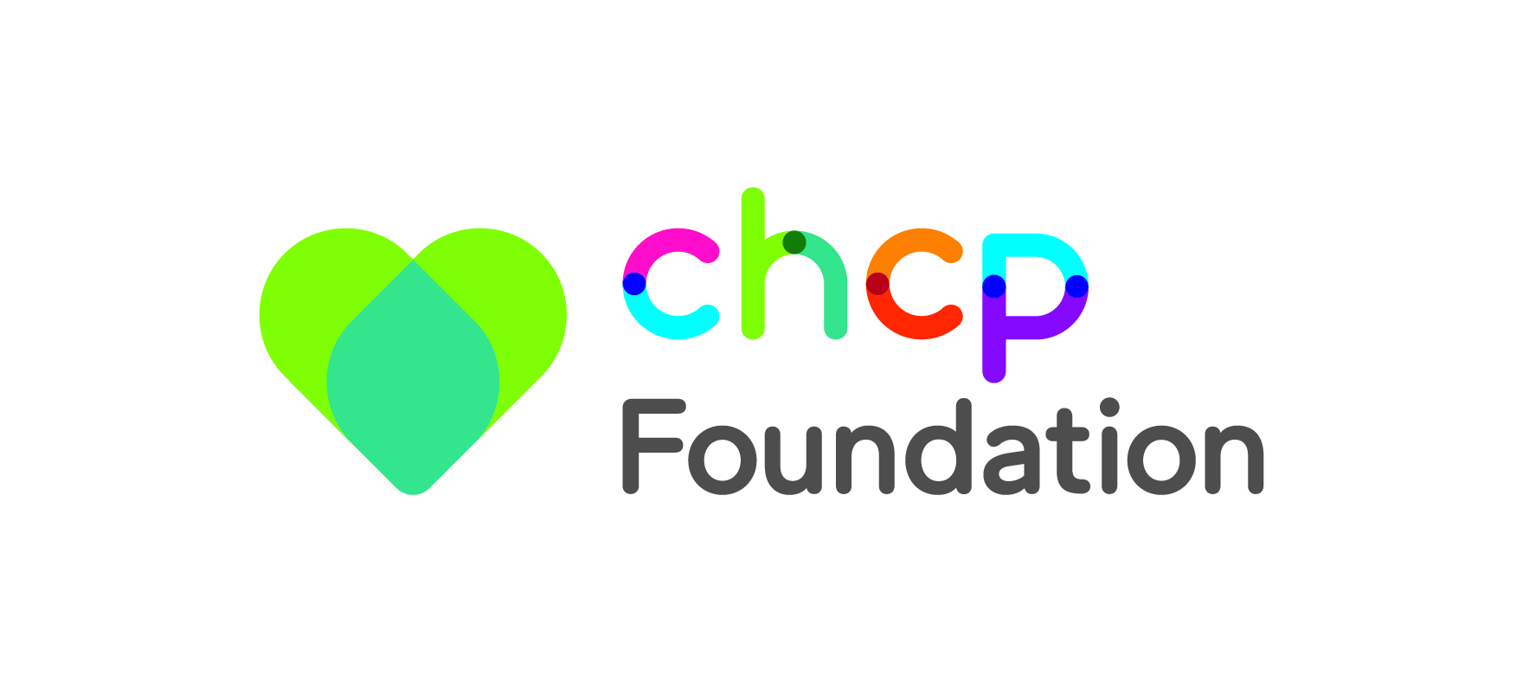
Application Reference __________________

City Health Care Partnership Foundation
Small Grant Application Form
***up to £2,500***

Section 1 - About Your Organisation

1.1 | Name of your organisation
1.2 | Name of main contact
 | Address
 | Postcode
 | Telephone Number
 | Email Address
 | Please note this email address will be used to notify you of the outcome of your application
 | Website Address

1.3 When did your organisation start? Month Year

1.4 What type of organisation are you? (Tick as appropriate).

A not-for-profit organisation, if yes, please give your company number _________________ A voluntary or community group.

Other: Please specify: _______________________________________

1.5 Please describe the overall aims and objectives of your organisation and the activities or service it provides.

Section 2 – About your grant application

2.1 Is this grant for (please tick one): New work Existing work
2.2 Is this grant for beneficiaries in (please tick all that apply): Hull East Riding Merseyside
St Helens

2.3 If your project has start and finish dates, enter them below. If not, give the details the period the funding will cover.

Project Start  Date |  | Project Finish  Date

2.4 Please select from the following CHCP Foundation health and wellbeing objectives to indicate which your project will contribute towards (you may select more than one):

Improvements towards the health and wellbeing of adults

Improvements towards the health and wellbeing of children and young people

Improvements in public health of communities, such as healthier lifestyles, stopping smoking, eating well and becoming more active

Improvements to specialist areas of health and wellbeing, such as addictions and mental health services

Please answer the following questions ensuring your response is no more than 250 words per section.

2.5 What are you planning to do?

2.6 Who will benefit from this activity and in what ways? How will your project contribute to the health and wellbeing of local people? (please tell us about any particular target groups)

2.7 How will you promote the activity and to whom?

2.8 Please tell us how this project will ensure equality and diversity are considered when you’re looking at who will benefit from the project

Section 3 – Funding Required (Maximum £2,500)

Please Note: we will not fund 100% of project costs – a contribution towards total costs should be specified. Please indicate with an asterisk (*) in the breakdown in 3.5 which areas/items of spend are required as a minimum

3.1 What is the total project cost £ _____________

3.2 How much money are you applying for: £ _____________

3.3 What other monies have been secured? £ _____________

3.4 Please tick to confirm that your project will go ahead on the basis of the contribution requested in 3.2 above

3.5 Budget breakdown summary

Please provide a breakdown of costs under separate headings for example staff costs, equipment, publicity and activity costs. Please also provide a cost breakdown i.e. 10 hrs @ £10 - £100.

Funding can be used for capital or revenue purchases and costs. Please attach a quote for any items to be purchased i.e. equipment, publicity, trainer fees and premises hire. Applicants must ensure value for money so it is recommended that you obtain more than one quote.

Any grant awarded and payment made is deemed inclusive of VAT where applicable.

Budget Heading | Detail of expenditure | Cost
 | TOTAL

Section 4 – Declaration

The person completing this form and another member of the organisation must sign the declaration below.

Please check that all sections of the form have been completed, read the following statement and sign below.

We confirm that the information in this form is correct. If a CHCP Foundation Small Grant is awarded, it will only be used for the purpose given and according to any conditions specified.

We understand that we will need to provide any additional relevant documentation upon request. We understand that we will be liable to repay the grant in full, if it is found that any of the information supplied is incorrect or if any grant monies that may be awarded are not used as indicated in this application form.

We understand that if a grant is awarded, we may be expected to work with CHCP Foundation to publicise the project, activity or event, as well as provide information on the progress of the project including case studies to demonstrate the impact of the award.

By signing this declaration, you are confirming that the organisation:
`
- is a Not-for-Profit Organisation, Community or Voluntary Group
- has a written set of rules, governing document or constitution (a copy should be submitted with your application)
- works for the benefit of the local community (Hull, East Riding, St Helens or Merseyside)
- is led by volunteers
- has a health and safety policy? (Copies must be provided upon request):

Yes No

- if appropriate to the planned activity, please confirm that you have a child protection policy and/or vulnerable adult policy? (Copies must be provided upon request):

Yes No

- all people who will be working with children are DBS checked:

Yes No

- has in place suitable and sufficient insurance in respect to beneficiaries and as legally required (Copies must be provided upon request).

Employer’s Liability Insurance

Yes No Value of cover £

Public Liability Insurance

Yes No Value of cover £

Signed | Print Name | Position | Date

Section 5 – Checklist

Please check the following, your application will not be considered if you have not. Failure to supply appropriate supporting documentation will result in your application being deferred or rejected.

You have completed all the questions

You have enclosed a copy of your governing document / constitution

You have included the relevant quotes to support your budget

You meet all of the eligibility criteria and have signed the declaration

CHCP are committed to protecting and respecting the privacy of your personal data. This privacy notice explains how your data is collected, used transferred and disclosed. It applies to data collected when you apply for a small grant.
By completing a small grant application form you are allowing us to use your name, telephone number, address, email address and organisation start date to help us monitor the impact of and improve our grants scheme, aid future research and contribute to NHS performance statistics.
Your details will remain confidential and will not be shared with any third party.
For further information on ‘Your information and how we use it’ visit www.chcpcic.org.uk

Please send your completed form to: chcp.foundation@nhs.net by the deadline for this round of awards or to:

Communications Manager
City Health Care Partnership Foundation
5 Beacon Way
Hull
HU3 4AE

