Dry Mouth Products
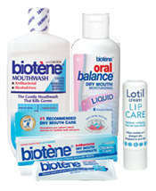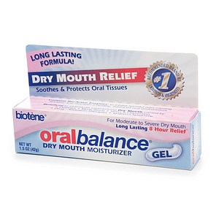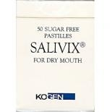
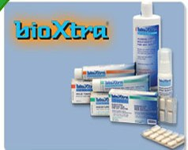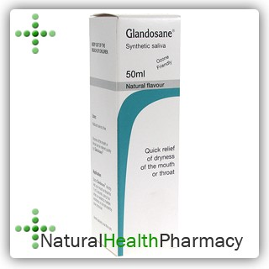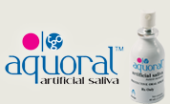

Here are some price examples of the above products if they are bought over the counter.
These items can also be prescribed by a dentist or doctor.
Biotene
Dry mouth anti bacteiral toothpaste 75ml approx £7.00
Dry mouth moisurising mouth wash 50ml approx £10.50
Dry mouth gel 50g approx £10.00
Moisturing liquid 45ml approx £10.00
Glandosane ( Should not be adviced for anyone with natural teeth as it is acidic and cause tooth erosion)
Synthetic saliva approx £9.00
Salivix
50 pastilles approx £8.50

Prices correct on date of printing in 2017

