Free Tooth Brushing Apps

Brush DJ

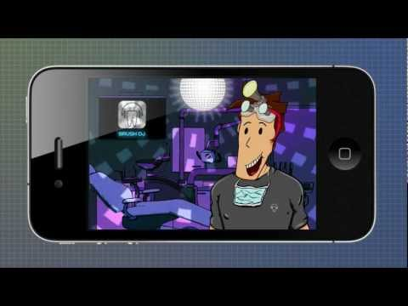

This free award-winning app, plays 2 minutes of music, taken at random or from a playlist, from your devices music library and has a visual display showing where to brush- finally brushing becomes less boring!

Aquafresh Brush Time
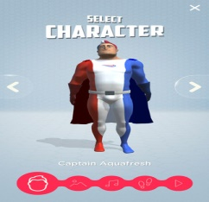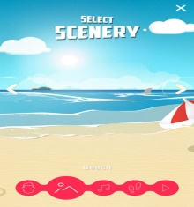

Captain Aquafresh and the Nurdles show kids a fun way to brush all parts of their teeth correctly. Catchy songs and dances get them brushing and help get them to the 2 minutes of brushing that dentists recommend. And because they’re having so much fun, before they know it, they’re done! Use the tunes in the app or link into your favourite playlists to provide endless dance mix-ups for variety every time they brush.

Disney Magic Timer by Oral-B

Now featuring twenty-three of your favorite Disney, Marvel and Star Wars characters, use this app to seamlessly encourage your kids to brush longer. Collect a new digital sticker after each successful two minutes of brushing; track progress with stars and milestone badges on the Brushing Calendar.

