Be Food Smart at the shops

Download the follow apps from Change for Life - ‘Sugar Smart’ app to calculate the sugar contents in foods and drinks
‘Food Smart’ app to identify the level of sugar, fat and salts in food and drinks

Scan barcodes using the app to find out how much sugar, saturated fat and salt is in food and drink. Simple!

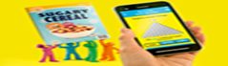

If you don't have the app...

Some food labels have traffic light coloured labels to show the sugar content. Choose more greens and ambers, and fewer reds.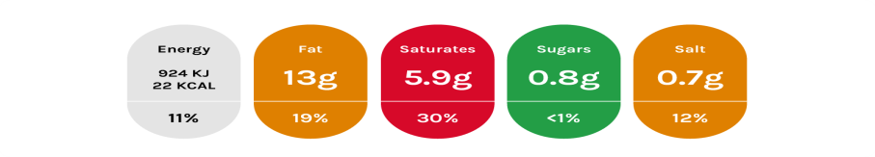
Red means this food is HIGH in sugar. Think about how often you choose it and how much of it you eat.
Amber means this food has a MEDIUM amount of sugar. This makes it an OK choice, although going for green is even better.
Green means it's LOW in sugar, which makes it a healthier choice

