MY 2020 COVID -19
TIME CAPSULE

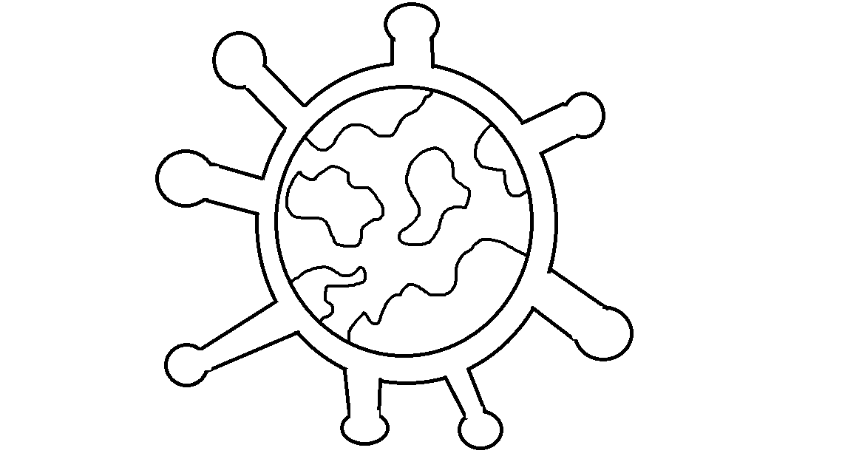

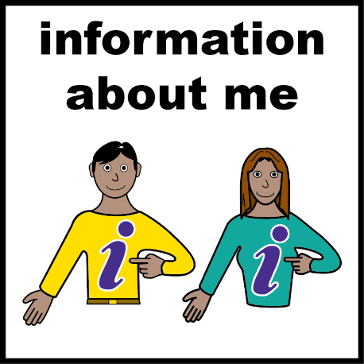

BY:

You are living through history right now

This is a space for you to show people the things you have been doing – Things you can put here are;
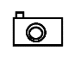
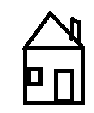
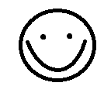
Photos during this time Artwork you have made
Family / pet pictures Special memories

Who are you spending this time with? Draw them here.

All about me

My age is My Favourite List
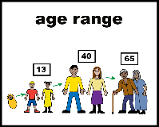
Toy
Colour
My hair colour Animal
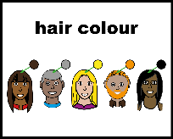
Food
Show
Song
My eye colour Movie
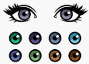
Place
Eye Colour
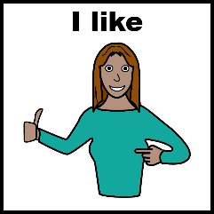
Activity

Date
My best friends are… 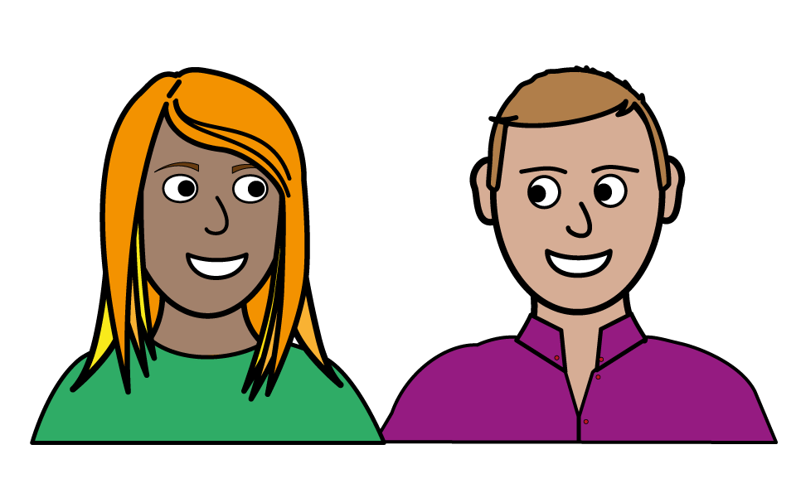
What do I want in the future?

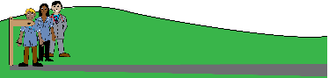

How I am feeling
Words to describe how I feel today…
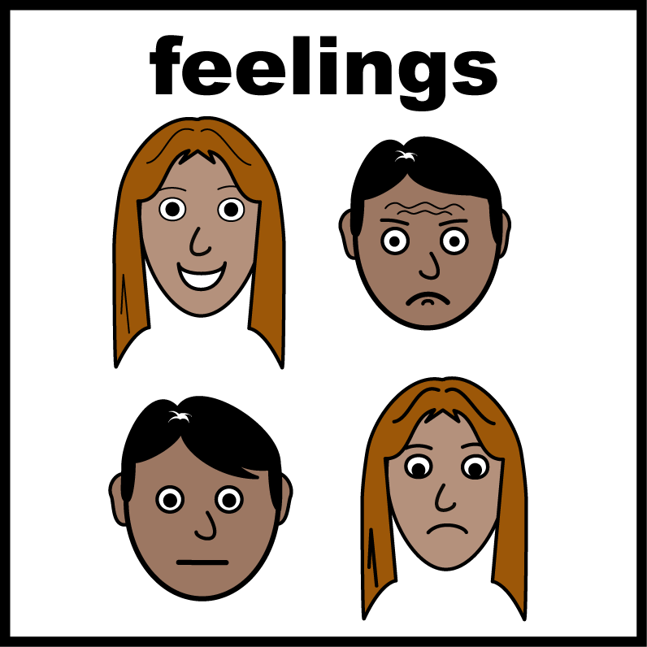
How my face looks

What I have learnt from this?
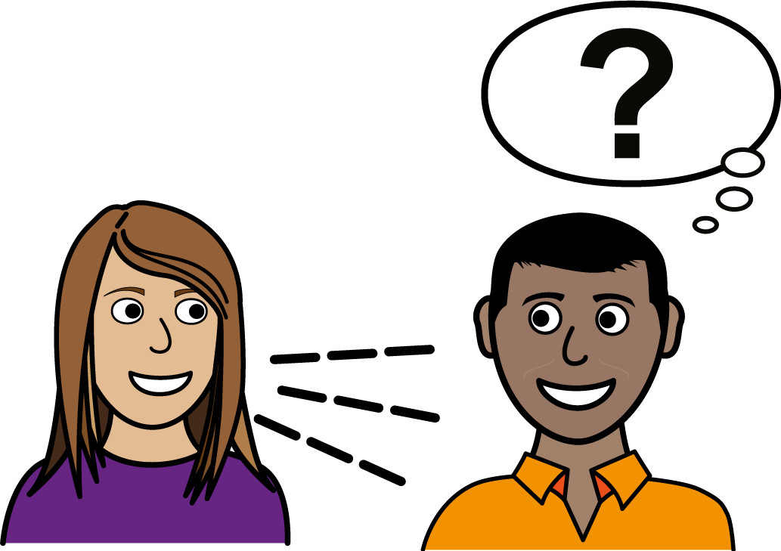

Things I am most thankful for…
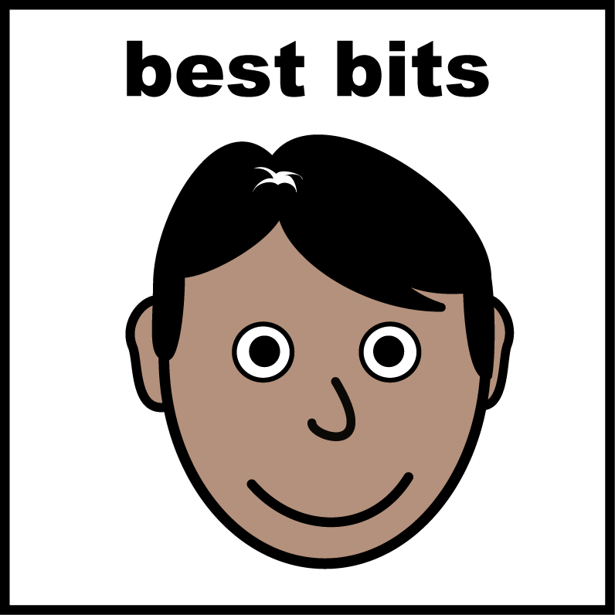

3 things I am most excited to do when this is over…

My community
Where I am living during this time?

Draw a picture of your home
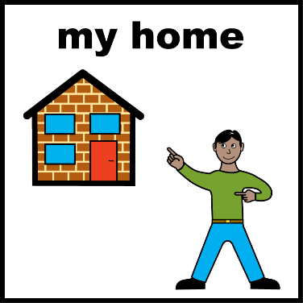

What have you done to keep in touch with people you love?
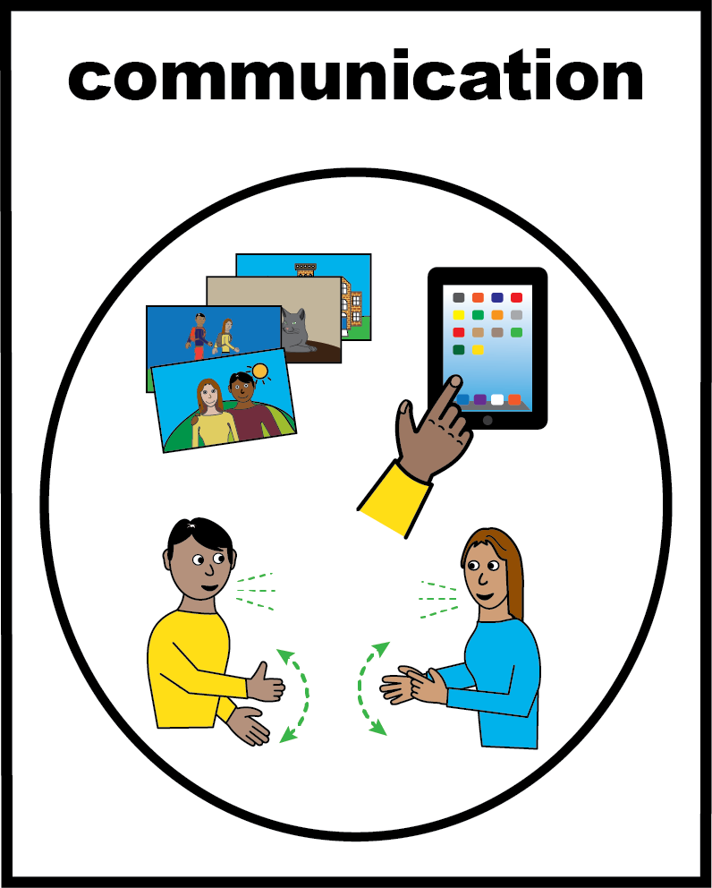
You are not stuck at home!
You are safe at home

Fun things I’ve done
During
Lockdown 2020

Our handprints
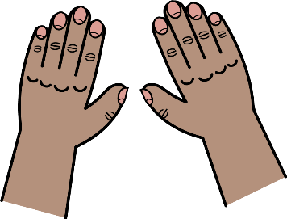
Draw around all the hands of the people living in your home and colour them in below.

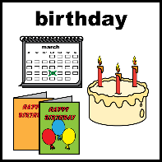
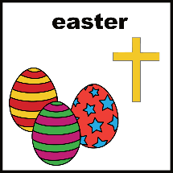
Special occasions
Did you have any celebrations during Lockdown 2020? Write the list down here and what you did to celebrate
(eg easter, birthdays, anniversarys)

EVENT | DATE | HOW YOU CELEBRATED
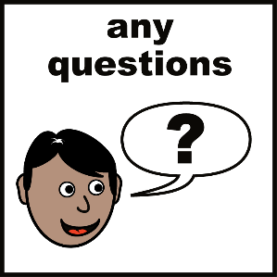
Interview people that are living with you

What has been the
Biggest change? How are you finding
Home-schooling?

How are you feeling today?

Your top 3 moments during this time
1 -
2 -
3 –

What TV shows or films have you enjoyed?-

Favourite food to bake -
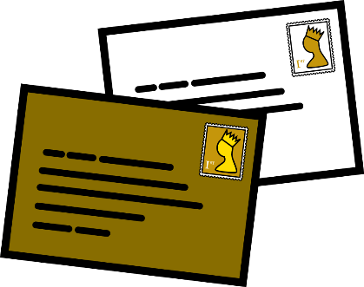
Write a letter to the people who are living with you

Date……………….
Dear…………………….
…………………………………………………………
…………………………………………………………
…………………………………………………………
…………………………………………………………
…………………………………………………………
…………………………………………………………
…………………………………………………………
…………………………………………………………
…………………………………………………………
…………………………………………………………
…………………………………………………………

Love from …………………………………

A letter from the people who are living with you

Date.………………
Dear…………………….
…………………………………………………………
…………………………………………………………
…………………………………………………………
…………………………………………………………
…………………………………………………………
…………………………………………………………
…………………………………………………………
…………………………………………………………
…………………………………………………………
…………………………………………………………
…………………………………………………………

Love from…………………………………

